AS-IS Doccuments BPMN 2.0 Legend

Symbol | Element | Description
((○)) | Start Event | Process begins
((●)) | End Event | Process ends
[Task] | Task/Activity | Process step
{X} | Exclusive Gateway | Decision - ONE path only
{+} | Parallel Gateway | Fork/Join - ALL paths
--> | Sequence Flow | Normal flow
-.-> | Loop Back | Return to previous step

- Children Services
Ministry: Ministry of Labour and Social Protection
Department: State Department for Social Protection

Attribute | Description
Key Actors | Reporting Party, Children Officers, Case Committees, Courts
Key Systems | Manual paper-based case management

  - Reporting Process
Record Details
Assign Officer
Assign Reference
Document Child Info
○

●
Create Case File

  - Intake Assessment
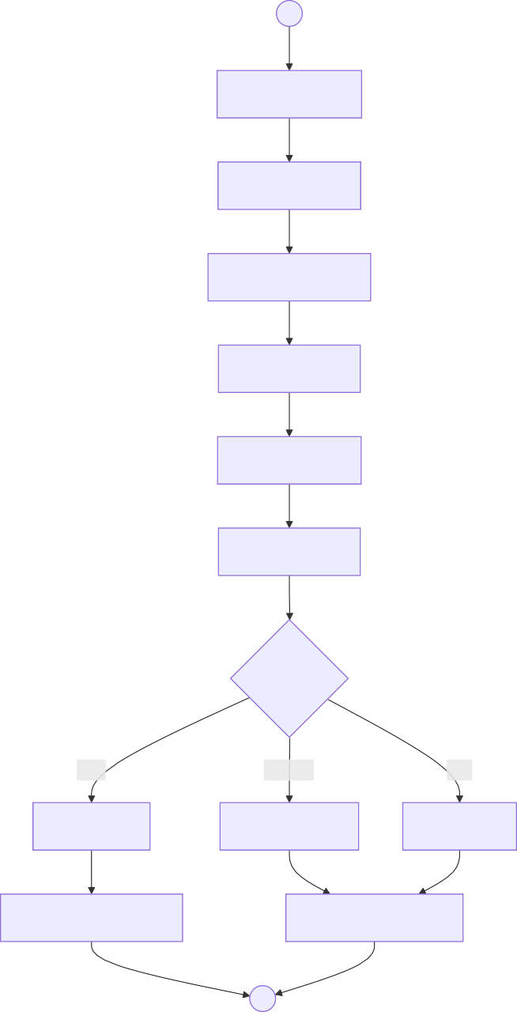
○
Review Report
Check History
Contact Reporter
Assess Safety
Evaluate Risks
Assess Family
Risk Level?
High
Medium
Low
HIGH Risk
MEDIUM Risk
LOW Risk
Emergency Removal
Standard Response
●

  - Investigation

●
Analyse Findings
Review Case File
Plan Steps
○
Visit Home
Schedule Visits
Observe Conditions
Interview Parents
Interview Child
Obtain School Records
Collect Medical Reports
Prepare Report

  - Case Planning
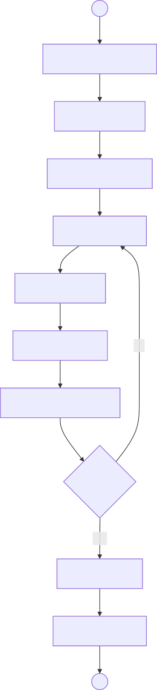
○
Review Investigation
Identify Needs
Assess Resources
Draft Care Plan
Set Objectives
Define Timeline
No
Present to Committee
Approved?
Yes

Approve Plan
Document Plan
●

  - Intervention
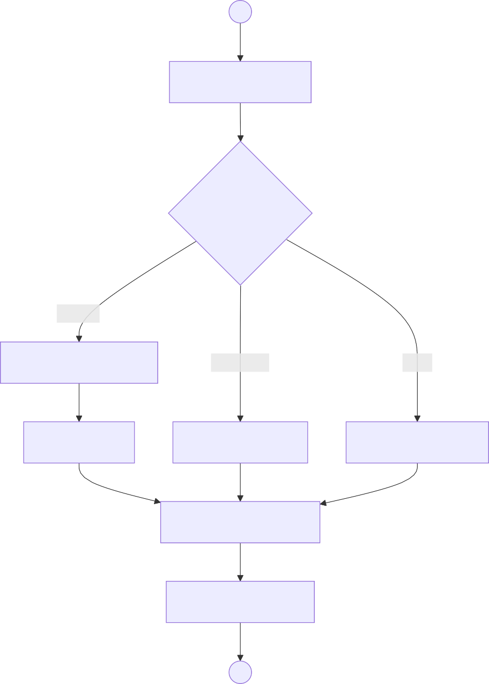
○
Review Care Plan
Intervention Type?
Support
Parenting Education
Placement
Legal
Counselling
Alternative Care
Court Application
Execute Intervention
Document Actions
●

  - Monitoring


Not Met
Prepare Report
Recommend Closure
Continue Plan
Update Plan
Achieved
Partial
Check Objectives
●
Objectives Met?
Conduct Visit
Document Findings
Schedule Review
○
Assess Progress
Consult Child

  - Case Closure



●
Approve Closure
Archive Case
Link to Resources
Prepare Closure Report
Final Consult
Develop Exit Plan
○
Confirm Achieved
Review History

  - End-to-End Child Protection



●
Case Registered
Risk Assessment
○
Evidence
Home Visit
Conference
Care Plan
Reviews
Intervention
Archive

Youth Affairs
Ministry: Ministry of Public Service, Gender and Affirmative Action
Department: State Department for Youth Affairs

Attribute | Description
Key Actors | Youth Applicants, Programme Officers, Film Officers, AGPO Officers
Key Systems | e-Citizen, IFMIS

  - Youth Internship Placement

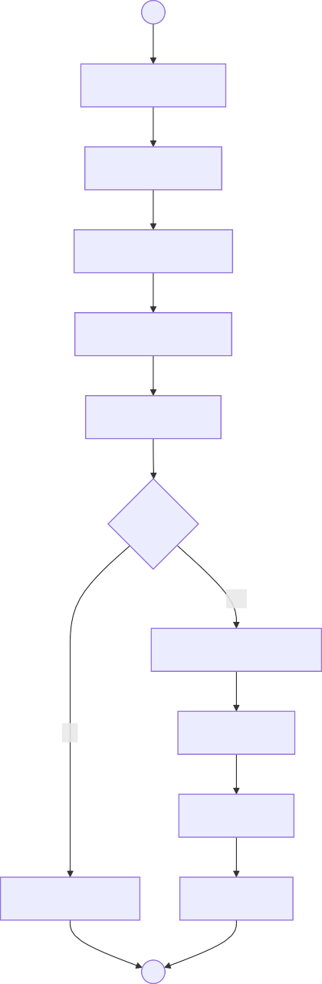
○
Access e-Citizen
Complete Form
Upload Documents
Review Application
Verify Eligibility
Eligible?
Yes

Search Opportunities
No
Match Skills
Issue Letter
Notify Rejection
Notify Host
●
  - AGPO Registration



●
○
Attach Business Registration
Complete AGPO Form
Attach ID Documents
Verify Ownership
Review Documents
Approve Registration
Verify Age 18-35
Generate Certificate
Update Registry
  - Film Production Licensing



●
Approved?
No
Yes
Request Revisions
Assess Locations
Pay Fee
Review Script
○
Complete Form
Location Details
Submit Script
Generate Permit
Issue Permit
  - End-to-End Youth Services

Application
Placement
Matching
Verification
○

●
Monitoring

Civil Registration Services
Ministry: Ministry of Interior and National Administration
Department: Department of Civil Registration Services

Attribute | Description
Key Actors | Parents, Informants, Registration Officers, Medical Officers, Chiefs
Key Systems | CRVS, e-Citizen

  - Birth Registration - Timely


○
Source?
Complete?
No
Yes
●
Issue Certificate
Print Certificate
Process Payment
Registrar Signs
Assign Entry Number
Enter in Register
Verify Parents
Review Documents
Attach Marriage Cert
Attach Parent IDs
Request More Docs
Complete Form
Hospital Notification
Community Report
Hospital
Home
  - Birth Registration - Late

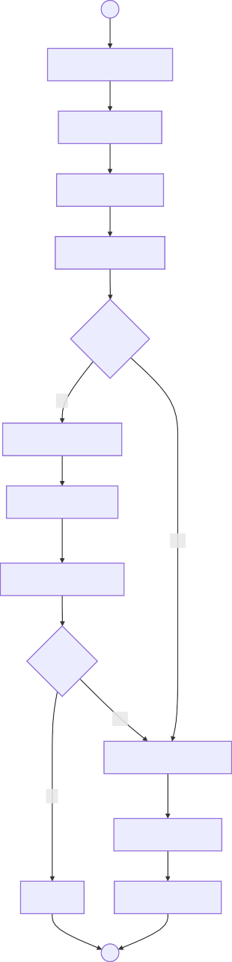
○
Complete Late Form
Attach Affidavit
Attach Evidence
Review Evidence
Sufficient?
No
Schedule Interview
Interview Parents
Yes
Interview Witnesses
Verified?
Yes
Approve Registration
No
Enter in Register
Reject
Issue Certificate
●
  - Death Registration

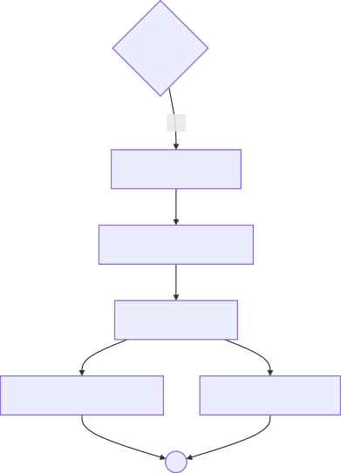
○
Source?
Complete?
No
Yes
Enter in Register
Assign Entry Number
Registrar Signs
Issue Death Certificate
Issue Burial Permit
●
Verify Cause
Review Documents
Attach ID of Deceased
Attach Death Certificate
Request More Info
Complete Form
Medical Certificate
Chief Report
Hospital
Home
  - Certificate Retrieval

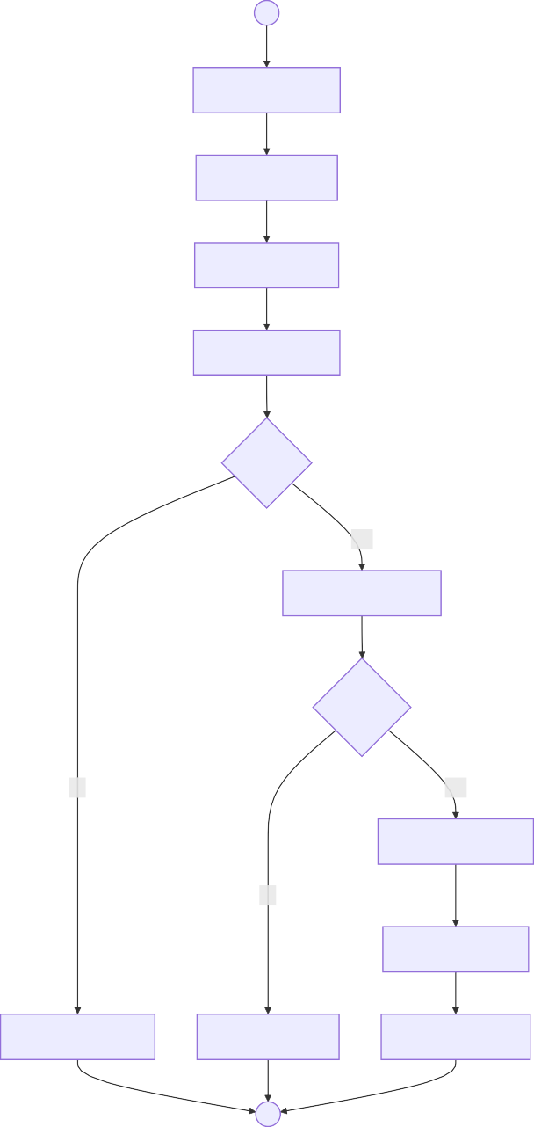
○
Submit Request
Provide Details
Pay Search Fee
Search Registry
Found?
Yes

Verify Entitlement
Entitled?
No
Yes

Process Payment
No
Print Certificate
Notify Not Found
Reject Request
Issue Certificate
●
  - End-to-End Civil Registration

Notification
Registration
Verification
Documentation
○

●
Certificate Issuance

Immigration - Passport Division
Ministry: Ministry of Interior and National Administration
Department: Directorate of Immigration Services

Attribute | Description
Key Actors | Applicants, Immigration Officers, Verification Officers, Production Unit
Key Systems | e-Citizen, IPRS, Passport Production System

  - First-Time Passport Application

Verify Identity

Issue Passport

Complete Form

Access e-Citizen

Upload Documents

Validate Application

Pay Fee

Query IPRS
No
Yes
○

Schedule Appointment

Capture Photo

Flag for Review

Capture Fingerprints

Print Passport

Embed Security
●

Notify Applicant
Verified?
  - Passport Renewal


Surrender Old
Issue New
Notify Applicant
Print New Passport
Verify Fingerprints
Update Photo
Eligible?
Yes
No
Schedule Visit
Check Eligibility
○
Access e-Citizen
Enter Old Passport
Select Renewal
●
Reject
Pay Fee
Validate Old Passport
  - Passport Replacement

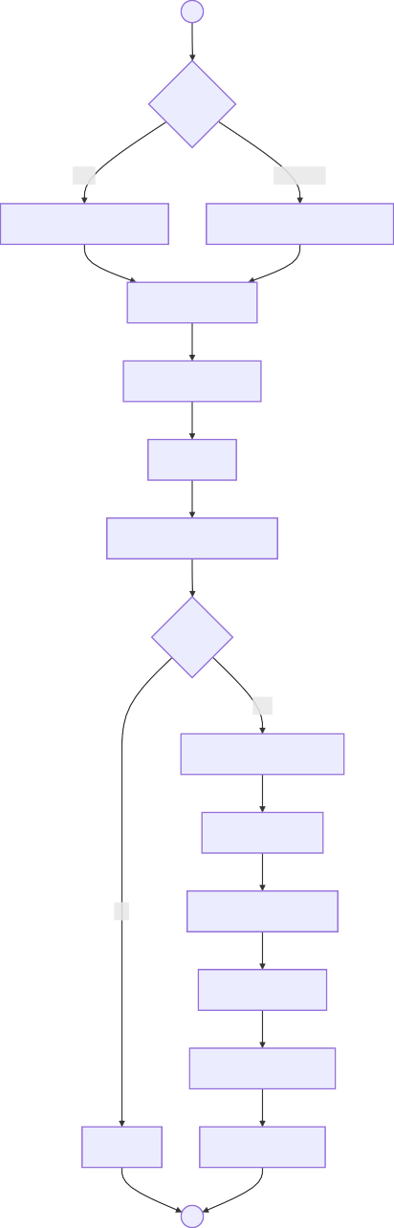
○
Reason?
Lost
Damaged
Obtain Police Abstract
Retain Damaged Passport
Complete Form
Upload Evidence
Pay Fee
Verify Original Records
Found?
Yes
Verify Police Abstract
Verify Identity
No
Capture Biometrics
Cancel Original
Print Replacement
Reject
Issue Passport
●
  - End-to-End Passport Services

Application
Production
Biometric Capture
IPRS Verification
○

●
Issuance

Refugee Services
Ministry: Ministry of Interior and National Administration
Department: Department of Refugee Services

Attribute | Description
Key Actors | Asylum Seekers, Refugees, Registration Officers, Eligibility Officers, RSD Committee
Key Systems | Refugee Registration System, UNHCR proGres

  - Asylum Seeker Registration



●
Issue Asylum Pass
Schedule RSD Interview
Generate AS Number
Capture Photo
Capture Fingerprints
○
Verify Entry Documents
Report to Registration
  - Refugee Status Determination


○
Decision?
●
Issue Letter
Deny
Committee Deliberates
Present to RSD
Prepare Report
Apply 1951 Criteria
Review Evidence
Record Testimony
Present Documents
Request More Info
Reject Claim
Grant Status
Defer
Grant
Attend Interview
  - Refugee ID Card Issuance

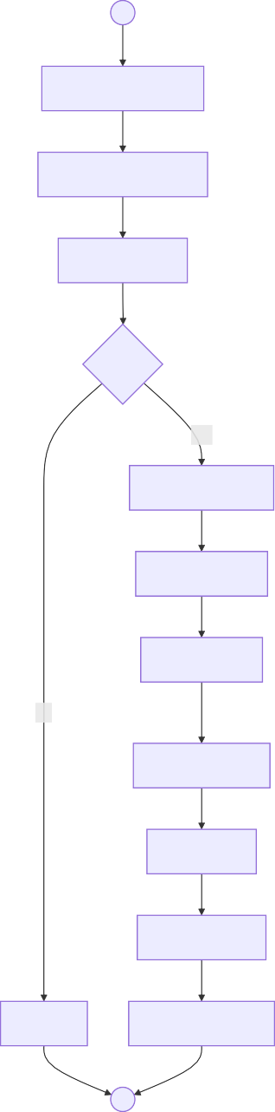
○
Submit Application
Present Recognition
Check Status
Valid?
Yes

Retrieve Record
Update Photo
Verify Prints
No
Generate Card
Print Card
Issue ID Card
Reject
Update Registry
●
  - Convention Travel Document

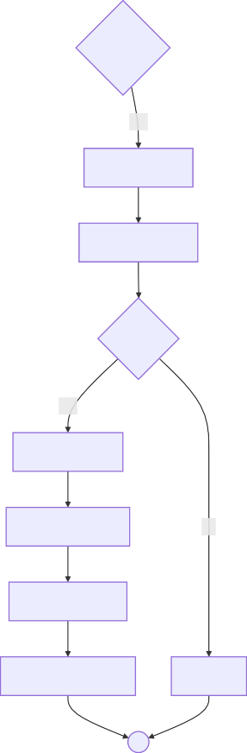
Yes
No
Process CTD
Print Document
No
Authorize CTD
Issue to Applicant
Reject
●
Return for Completion
Eligible?
Verify Purpose
Verify Status
Yes
Check Completeness
Complete?
○
Complete CTD Form
Pay Fee
Attach Documents
  - Appeal Process

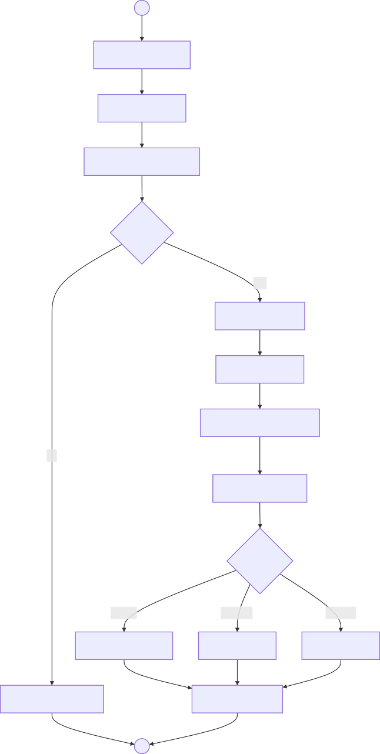
○
Receive Rejection
Prepare Appeal
Submit Within 30 Days
On Time?
Yes
Register Appeal
Review Original
Consider New Evidence
No
Conduct Hearing
Outcome?
Uphold
Overturn
Remand
Confirm Rejection
Grant Status
Re-interview
Reject Time-Barred
Notify Appellant
●
  - End-to-End Refugee Services



●
ID Card
Travel Document
Recognition
RSD Interview
Assessment
○
Asylum Pass
Registration

Energy - Records Management
Ministry: Ministry of Energy and Petroleum
Department: State Department for Energy - Records Management Unit

Attribute | Description
Key Actors | Registry Clerks, Records Officers, Action Officers, Archivists
Key Systems | Hybrid paper-digital system

  - Incoming Mail

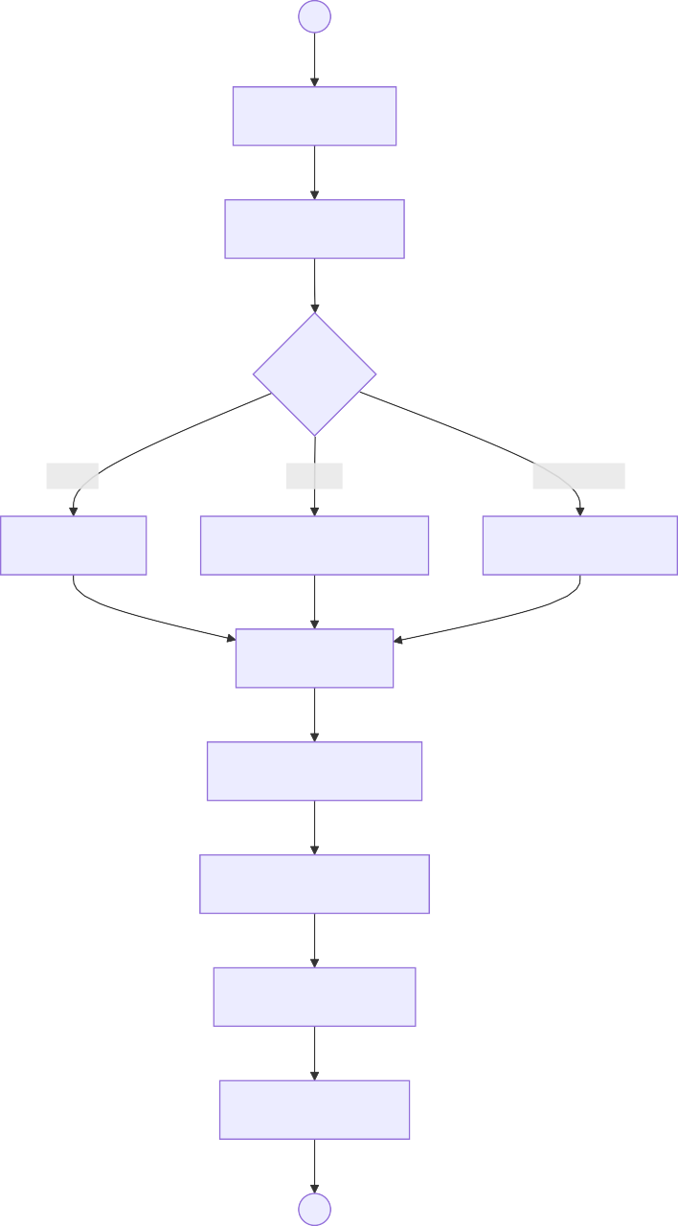
○
Receive Mail
Open and Sort
Priority?
Urgent
Normal
Confidential
Fast Track
Standard Processing
Secure Handling
Date Stamp
Classify by Subject
Register in Mail Book
Assign Reference
Route to Officer
●
  - Outgoing Mail



●
No
Yes
Obtain Approvals
Return for Correction
Approved?
○
Prepare Response
Submit for Dispatch
Assign Dispatch Number
Register in Dispatch Book
Make File Copy
Dispatch
Confirm Delivery
  - File Creation

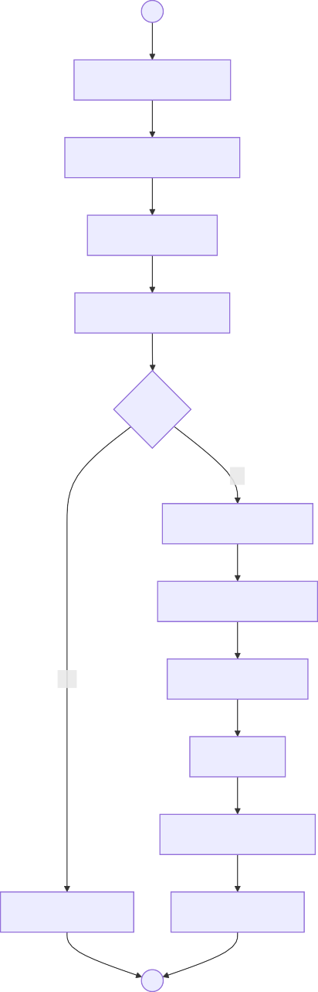
○
Identify Need for File
Complete Request Form
Submit Request
Search Existing Files
Exists?
No
Verify Classification
Assign File Reference
Yes
Create File Jacket
Label File
Register in File Index
Notify File Exists
Store in Registry
●
  - File Movement

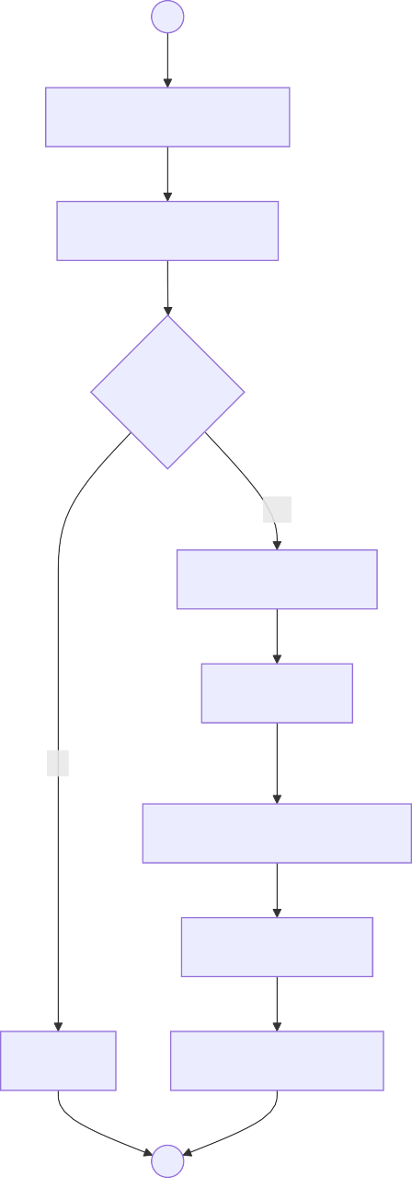
○
Complete File Request
Verify Authorization
Authorized?
Yes
Search File Index
Locate File
No
Record in Transit Register
Set Return Date
Reject
Issue to Requester
●
  - Records Archival

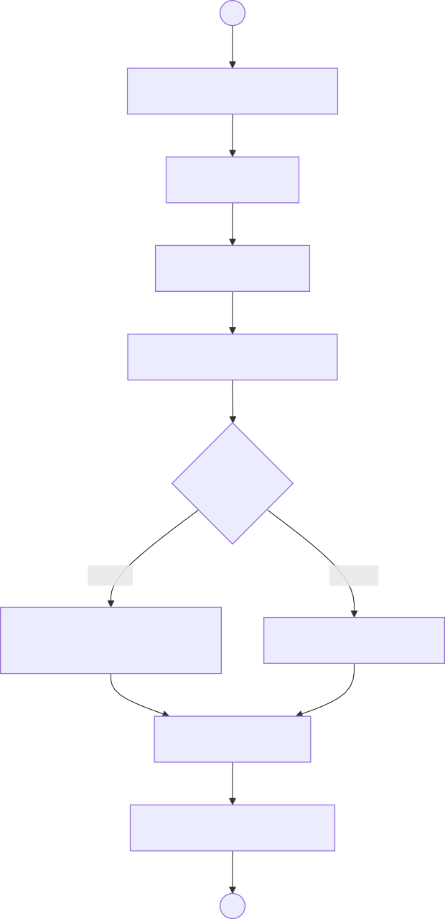
○
Identify Files for Appraisal
Retrieve Files
Review Contents
Apply Retention Schedule
Disposition?
Archive
Dispose
Prepare Archival
Description
Prepare Disposal List
Execute Decision
Update Records Register
●
  - End-to-End Records Management



●
Dispatch
Appraise
Respond
File
Route
Process
○
Register
Receive

MSME Development
Ministry: Ministry of Co-operatives and MSMEs
Department: State Department for MSME Development

Attribute | Description
Key Actors | MSME Applicants, Fund Officers, Credit Committees
Key Systems | Hustler Fund Portal, Uwezo Fund System, IFMIS

  - Hustler Fund Application

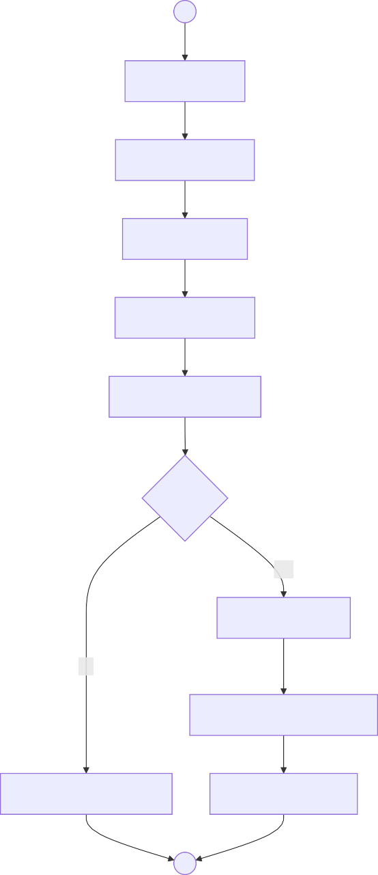
○
Access Portal
Register Account
Complete KYC
Verify National ID
Check Credit Score
Eligible?
Yes

Calculate Terms
No
Disburse to Mobile Money
Flag for Manual Review
Send Confirmation
●
  - Hustler Fund Repayment

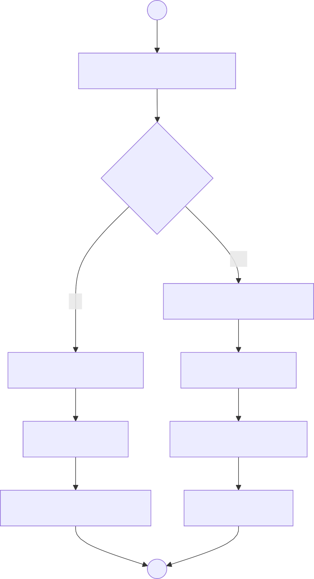
○
Send Payment Reminder
Payment Made?
Yes
No
Match to Loan Account
Send Default Notice
Update Balance
Apply Penalty
Update Credit Score
Update Score Negative
Close Account
●
  - Uwezo Fund Registration


Approved?
No
Yes
Issue Certificate
Enter in Registry
●
Return for Corrections
Verify Group Composition
Attach Constitution
Submit to Sub-County
Attach Member IDs
Complete Registration Form
○
Form Group 10-15 Members
Open Bank Account
Elect Officials
  - Uwezo Fund Loan

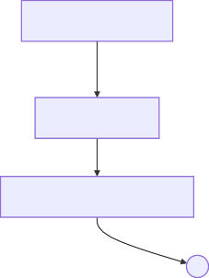
Approve
Info
Prepare Agreement
Members Sign
Disburse to Group Account
●
Notify Rejection
Reject
Request More Info
Develop Proposal
Committee Decision?
Complete Loan Form
Attach Documents
Prepare Appraisal
Review Proposal
Assess Viability
Submit Application
Verify Group Registration
○
  - NYOTA Apprenticeship

●
Final Assessment
Start Training
Match Apprentice
Find Master
Identify Trade
Review Application
Assess Skills
○
Upload Documents
Access Portal
Create Account
Sign Agreement
Prepare Agreement
Track Progress
Issue Certificate
  - End-to-End MSME Credit

Registration
Repayment
Disbursement
Verification
○

●
Credit History Update

Head of Public Service
Ministry: Executive Office of the President
Department: Office of the Head of Public Service

Attribute | Description
Key Actors | Head of Public Service, Principal Secretaries, Senior Coordinators
Key Systems | Executive Coordination Systems

  - Presidential Directive



●
Track Implementation
Identify MDAs
Analyse Requirements
Receive Directive
○
Translate to Instructions
Define Deliverables
Send to Ministries
Set Timeline
Confirm Receipt
Consolidate Updates
  - Information Request



●
Compile Submissions
Approve Request
Define Scope
Identify Information Need
○
Draft Request Letter
Define Format
Dispatch to All MDAs
Set Deadline
Monitor Submissions
Prepare Report
  - Policy Clarification

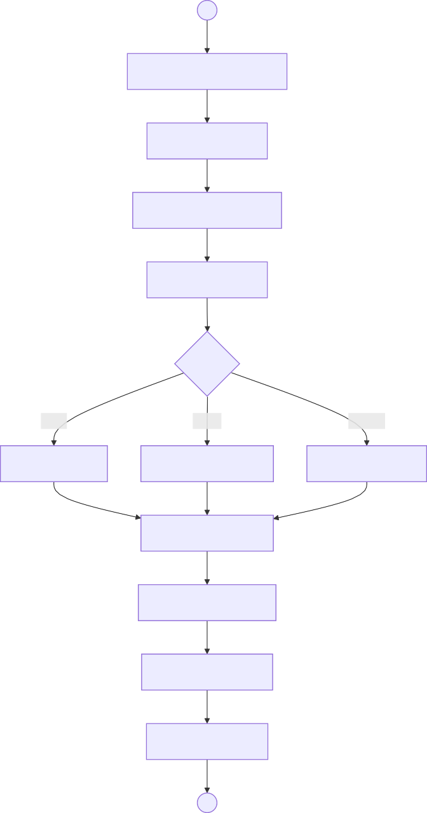
○
Identify Policy Ambiguity
Prepare Request
Submit to HoPS Office
Receive Request
Type?
Legal
Policy
Routine
Refer to Legal
Refer to Policy Unit
Address Directly
Consult Authorities
Formulate Guidance
Approve Response
Dispatch to MDA
●
  - Performance Monitoring

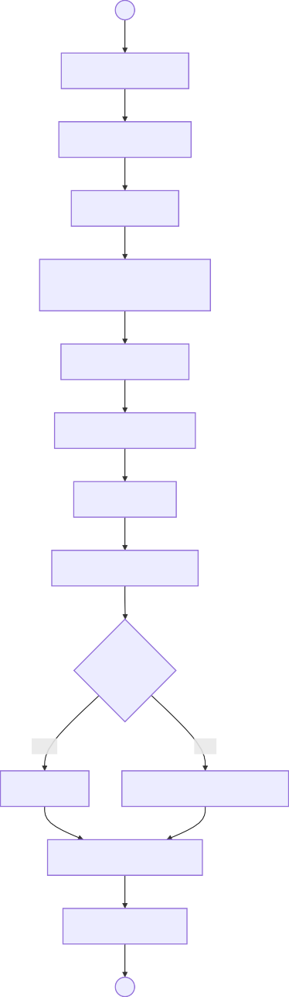
○
Define Parameters
Prepare Framework
Issue to MDAs
MDAs Submit Quarterly
Reports
Verify Data Quality
Analyse Performance
Identify Gaps
Identify Best Practices
Performance?
Good
Poor
Commend
Issue Corrective Directives
Communicate Feedback
Track Corrections
●
  - End-to-End Executive Coordination



●
Consolidate
Report to Leadership
Collect Responses
Issue to MDAs
Track Compliance
○
Translate Instructions
Directive Received

Cabinet Affairs
Ministry: Executive Office of the President
Department: State Department for Cabinet Affairs

Attribute | Description
Key Actors | Cabinet Affairs Officers, EDRMS Administrators, Fleet Managers
Key Systems | CABMEMO, EDRMS, GDMIS, Fleet Management

  - Cabinet Memorandum


○
Compliant?
No
Yes
●
Schedule for Cabinet
Consolidate Feedback
Receive Comments
Route to Treasury
Route to AG
Assign Reference
Log in CABMEMO
Submit to Cabinet Affairs
Obtain PS Approval
Return for Corrections
Prepare Memorandum
  - GDMIS Priority Registration



●
MDAs Acknowledge
Direct Registration
Define Outcomes
Identify Priority
○
Create Priority Record
Define KPIs
Assign Lead MDA
Set Milestone Dates
Notify Assigned MDAs
Activate Monitoring
  - Fleet Trip Management

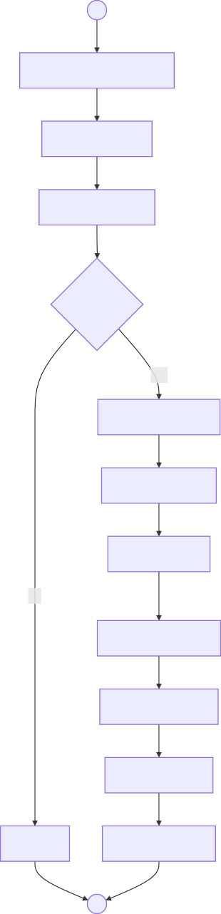
○
Complete Request Form
Specify Details
Obtain Approval
Authorized?
Yes

Check Availability
Allocate Vehicle
Assign Driver
No
Issue Work Ticket
Track Movement
Return Vehicle
Reject
Record Mileage
●
  - End-to-End Cabinet Affairs


Schedule for Cabinet
Review and Route
○
Progress Tracked
MDAs Assigned
Priority Registered
CABMEMO Received

●

Science, Research and Innovation
Ministry: Ministry of Education
Department: State Department for Science, Research and Innovation

Attribute | Description
Key Actors | Researchers, Research Officers, Programme Coordinators
Key Systems | Manual paper-based processing

  - Research Application



●
Assign to Examiner
Identify Examiner
Assign Reference
Review Category
No
Yes
Attach Documents
Return for Completion
Complete?
○
Complete Application
Submit Application
Log in Register
Issue Acknowledgment
  - Application Review

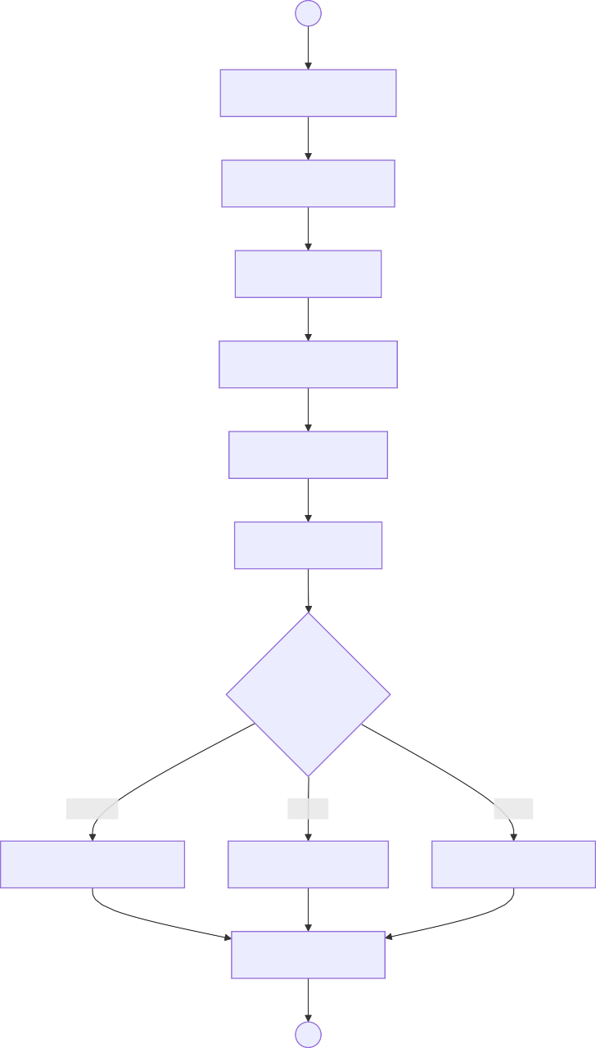
○
Receive Application
Review Documents
Assess Criteria
Verify Qualifications
Check Institution
Prepare Report
Recommendation?
Approve
Revise
Reject
Forward for Approval
Request Revision
Prepare Rejection
Notify Applicant
●
  - Payment Processing

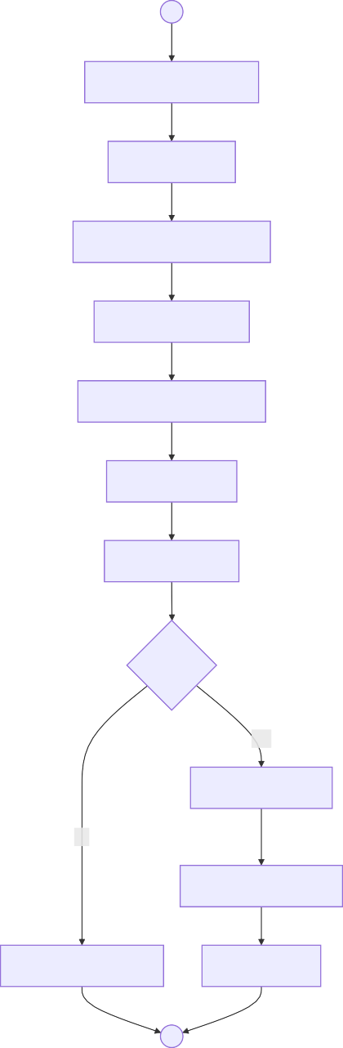
○
Retrieve Approved App
Calculate Fees
Generate Payment Request
Issue to Researcher
Researcher Pays via Bank
Submit Receipt
Receive Receipt
Verified?
Yes
Confirm Payment
No
Issue Official Receipt
Payment Not Verified
Attach to File
●
  - Public Inquiry



●
Record Details
Categorize Inquiry
○
Route to Officer
Assign Reference
Research Information
Prepare Response
Send Response
Obtain Approval
Log Closure
  - End-to-End Research Application



●
Payment Processed
Agreement Signed
Decision
Assigned to Examiner
Assessment
○
Logged
Application Received

Culture - Ushanga Kenya
Ministry: Ministry of Youth Affairs, Creative Economy and Sports
Department: State Department for Culture, Arts and Heritage

Attribute | Description
Key Actors | Cooperatives, Artisans, Quality Officers, Market Officers
Target | Over 90% product pass rate, Payment within 14 days

  - Product Submission

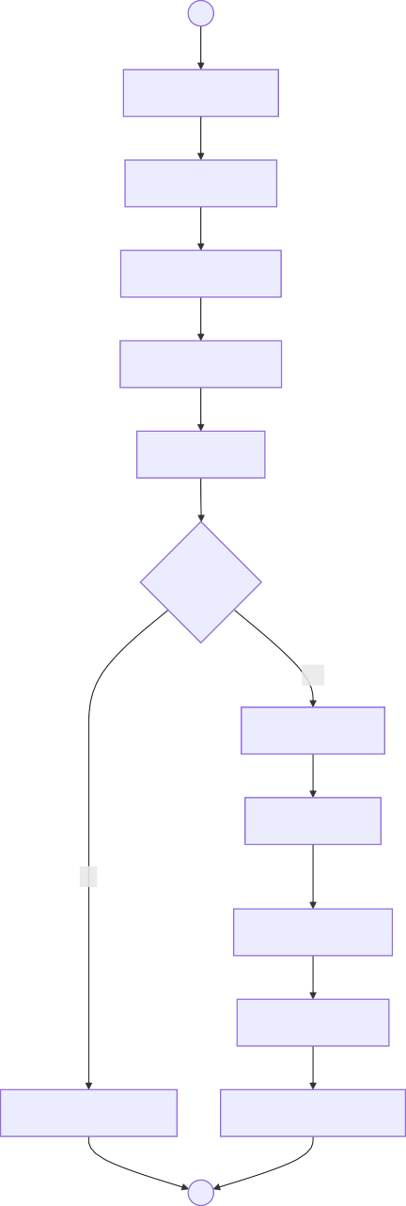
○
Gather Products
Travel to Center
Present Products
Receive Products
Count Items
Registered?
Yes
Record Details
Issue Receipt
No
Tag with Coop ID
Log in Inventory
Reject Unregistered
Store in Holding Area
●
  - Quality Inspection

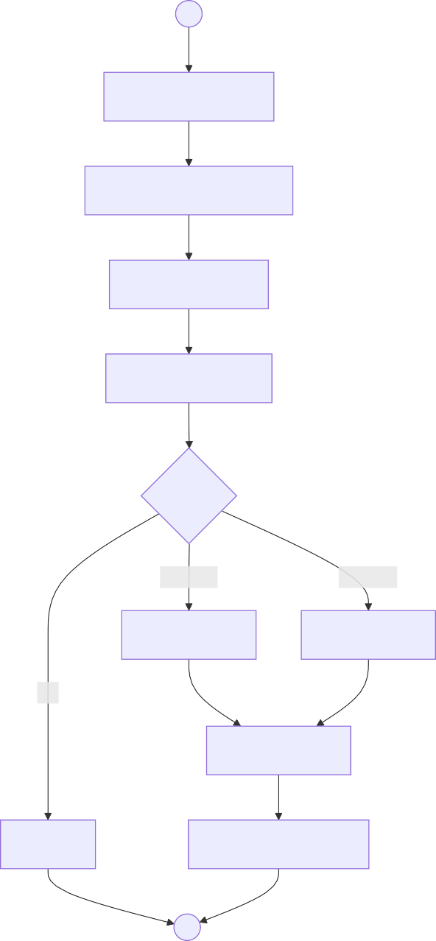
○
Retrieve Products
Examine Craftsmanship
Check Materials
Assess Durability
Grade?
Premium
Standard
Grade A Tag
Grade B Tag
Fai
Record Grade
Reject
Move to Cataloging
●
  - Market Placement

Retail | Exhibition | Online
Select for Retail | Select for Exhibition | Select for E-commerce

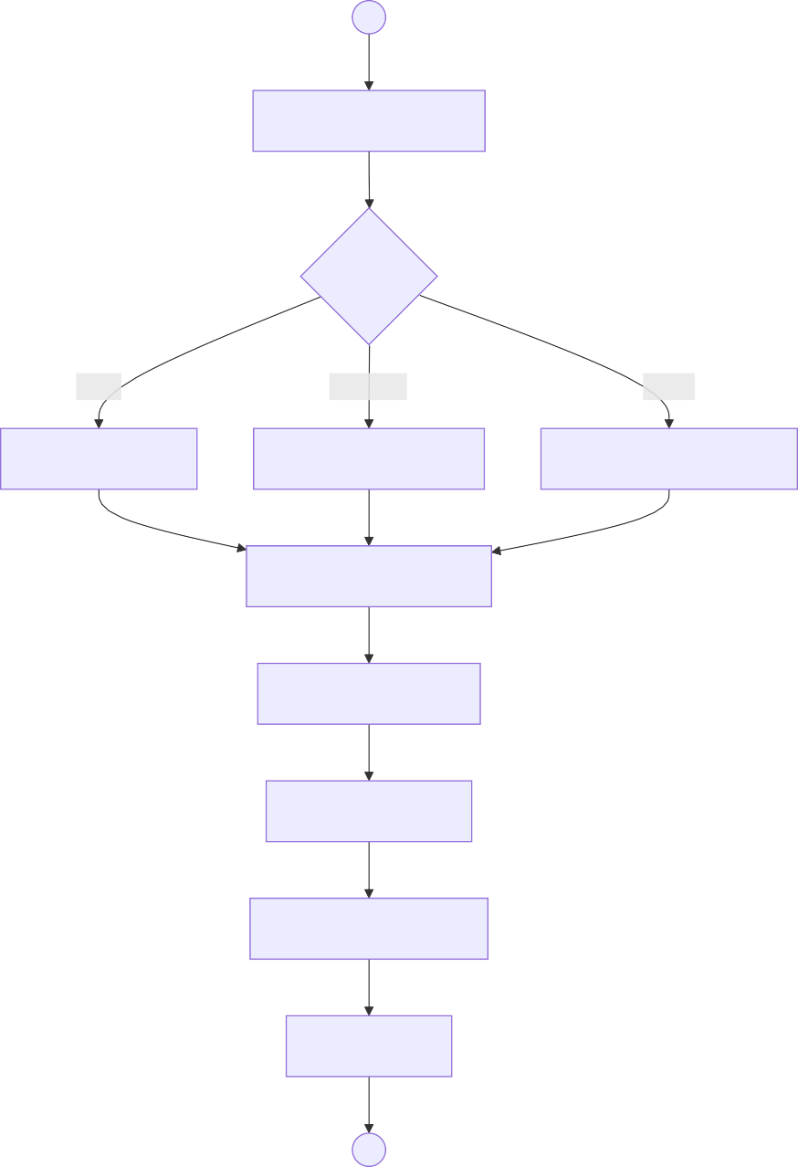
  - Payment Processing
○
Identify Opportunity
Channel?
Prepare Consignment
Dispatch to Market
Display Products
Customer Purchases
Record Sale
●

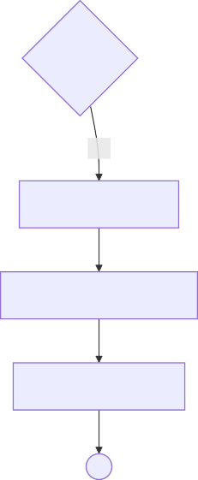
Approved?
No
Yes

Process Transfer
Generate Confirmation
Notify Cooperative
●
Query Discrepancies
Calculate Net Payment
Prepare Schedule
Calculate Gross Earnings
Deduct Management Fee
Identify Cooperatives
Receive Sales Summary
○
  - End-to-End Ushanga Kenya



●
Products Received
Inventory Logged
○
Grading
Inspection
Cataloged
Market Placement
Payment Processing
Sales
Cooperative Paid

Sports
Ministry: Ministry of Youth Affairs, Creative Economy and Sports
Department: State Department for Sports

Attribute | Description
Key Actors | Athletes, Sports Officers, Federation Representatives, Facility Managers
Key Systems | Sports Registration System, Grants Management

  - Federation Registration



●
Issue Certificate
Verify Representation
Complete?
No
Yes
Complete Form
Return for Corrections
○
Prepare Documents
Submit Application
Review Documentation
Verify Compliance
Check Leadership
Prepare Report
Approve
Update Registry
  - Athlete Grant Application

Prepare Agreement

Process Payment

Prepare Assessment

Review Budget

Reject Not Registered

Review Performance

Assess Purpose
Yes
No

Submit

Verify Registration

Attach Endorsement

Complete Form

Attach Records
○
●
Registered?

Submit to Committee
  - Facility Booking

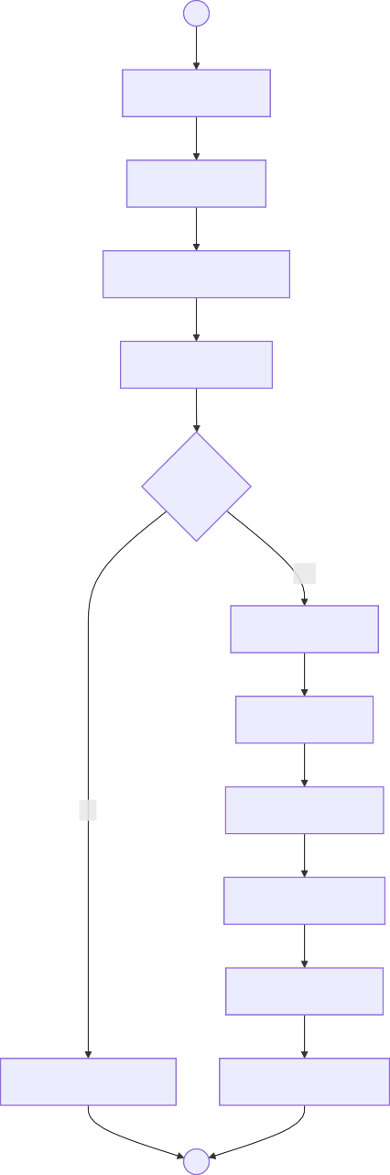
○
Access System
Select Facility
Select Date and Time
Submit Request
Available?
Yes

Verify Eligibility
Calculate Fee
No
Generate Invoice
Process Payment
Confirm Booking
Notify Not Available
Issue Confirmation
●
  - End-to-End Sports Services



●
Facility Booking
Maintenance
Competition Support
Talent Identification
Grants
○
Oversight
Federation Registration

AWWDA
Ministry: Ministry of Water, Sanitation and Irrigation
Agency: Athi Water Works Development Agency

Attribute | Description
Key Actors | Project Engineers, Design Teams, Contractors, Water Service Providers
Key Systems | Project Management System, GIS, IFMIS

  - Feasibility Study



●
Approved?
No
Yes
Request Revisions
Prepare Feasibility
Consolidate Reports
Environmental Assessment
Social Assessment
Calculate Demand
Technical Assessment
Collect Data
Identify Study Area
○
Proceed to Design
Document Approval
  - Procurement


Committee Decision?
●
Sign Contract
Award Contract
Approve
Re-evaluate
Technical Eval
Financial Eva
Preliminary Eval
Receive Submissions
Conduct Site Visits
Issue Documents
Respond to Queries
Confirm Budget
Publish Notice
Finalize Tender Docs
○
Prepare Report
  - Construction Supervision


No
Yes
Approve Works
Measure Works
Prepare Certificate
Process Payment
●
Issue Non-Conformance
Quality OK?
Inspect Work
Site Inspections
Material Testing
Monitor Progress
○
Mobilize Team
Review Contract
Establish Office
  - Commissioning

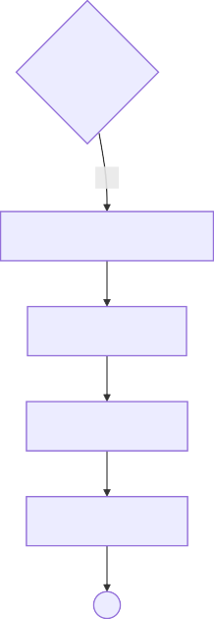
Transfer to WSP
Pressure Test
●
Quality Test
Flow Test
Remedial Works
Clear Items
Issue Certificate
Joint Inspection
No Yes

Compile Documentation
Tests Passed?
○
Prepare Punch List
Confirm Complete
  - End-to-End Infrastructure



●
Construction
Commissioning
Tender Documents
Procurement
Concept Design
Detailed Design
○
Feasibility
Demand Assessment

Agriculture and Food Authority
Ministry: Ministry of Agriculture and Livestock Development
Authority: Agriculture and Food Authority

Attribute | Description
Key Actors | Farmers, Traders, Export Agents, AFA Officers
Key Systems | KIAMIS, AFA IMIS, KENTRADE

  - Farmer Registration

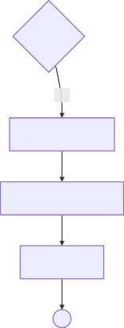
Verified?
No
Yes
Enter in KIAMIS
Generate Farmer ID
Issue Card
●
Return for Correction
Attach ID
Submit to County
Attach Land Documents
Assign Reference
Receive Application
Verify Identity
Log in System
Complete Form
○
Capture GIS Data
Verify Land
  - Export Permit


Notify Exporter
Generate Permit
Approve
Submit via IMIS
No
Yes
Verified?
Verify Quantities
System Receives
Generate Number
Verify Origin
Attach Contract
Attach Quality Certificate
Complete Form
Attach License
○
Verify Trader
Route to Directorate
Check Quality
Reject
●
Transmit to Customs
  - Trading License

Approve
●
Notify Applicant
Generate License
Notify Rejection
Update Registry
Reject
Request More Info
Assess Premises
Info
Decision?
Attach Business Registration
Complete Form
○
Submit Application
Attach Premises Docs
Review Documentation
Verify Capacity
  - End-to-End AFA Services



●
Certifications
Market Intelligence
Inspections
Export Permits
Trading Licenses
○
Trader Registration
Farmer Registration

Health
Ministry: Ministry of Health
Division: Health Information Systems

Attribute | Description
Key Actors | Patients, Health Facilities, County Health Departments, SHA, KHIE
Current State | Facility-centric, fragmented identifiers
Target State | Patient-centric, unified health record
Volume | 55M patients, 300-400M annual encounters

  - Current State - Fragmented



●
Patient Arrives Facility A
New Registration
○
Patient Arrives Facility B
Assign Facility ID
No Record Found
New Registration B
Multiple IDs
Assign New Facility ID
Fragmented History
  - Target State - BHI



●
Enroll New Patient
e-Prescribe
Record Encounter
Active Medications
Query National SHR
View History
Retrieve Existing ID
Prior Lab Results
Query Registry
○
Found?
No
Biometric Scan
Yes
Clinical Consultation
Push to KHIE
Update SHR
  - KHIE Architecture

●
Public Hospitals
Private Facilities
○
Laboratories
Pharmacies
FHIR Adapter
Data Validation
Message Broker
Patient Registry
Patient Matching
Shared Health Record
SHA Claims
Disease Surveillance
  - AfyaYangu Portal

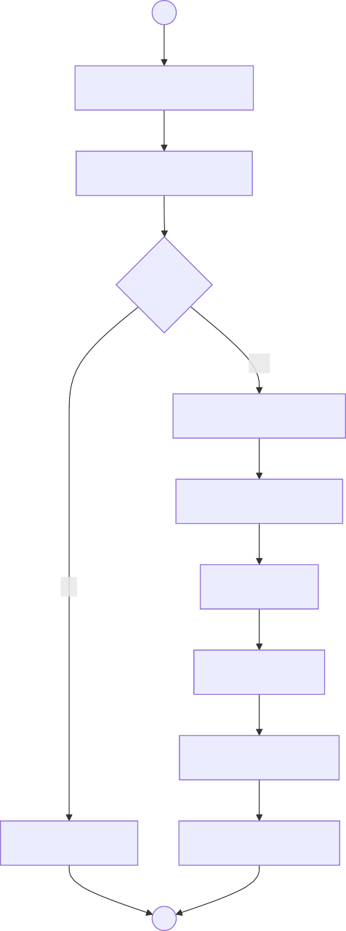
○
Login with National ID
Biometric Verification
Verified?
Yes

View Health Records
Prescription History
No
Lab Results
Claims Status
Book Appointment
Access Denied
Download Records
●
  - End-to-End Health Information



●
Push to SHR
Query KHIE
Patient Matched
Biometric Scan
○
Get Health Record
Consultation
Treatment
Diagnosis
Document Encounter
Patient Portal

Education - KNQA
Ministry: Ministry of Education
Authority: Kenya National Qualifications Authority

Attribute | Description
Key Actors | Applicants, Technical Officers, Review Committee
Key Systems | National Qualifications Validation Registry

  - Qualification Application



●
Validate Transcripts
Check for Fraud
Verify Institution
Log in System
No
Yes
Attach Documents
Return for Completion
Complete?
○
Submit Application
Pay Fee
Authenticate Certificates
Forward for Assessment
  - Qualification Assessment

○
Decision?
Info
●
Issue to Applicant
Apply Digital Signature
Generate Letter
Approve
Committee Deliberates
Present to Committee
Document Rationale
Determine Level
Assess Against KNQF
Prepare Rejection
Update Registry
Reject
Request More Info
Receive Verified Docs
  - Recognition of Prior Learning

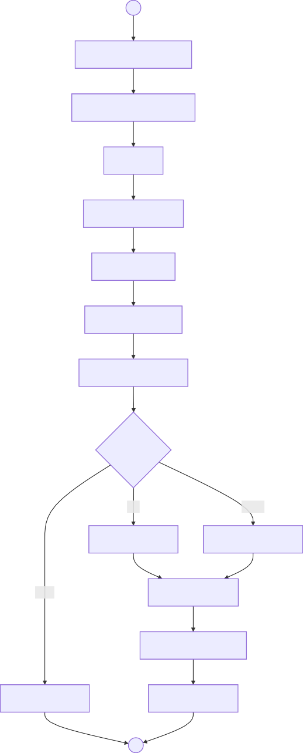
○
Submit RPL Application
Attach Evidence Portfolio
Pay Fee
Review Application
Assess Claims
Evaluate Evidence
Conduct Assessment
Equivalence?
Full
Partial
Full Recognition
Partial Recognition
None
Issue Certificate
Register in Database
Not Recognized
Notify Applicant
●
  - Validation Registry

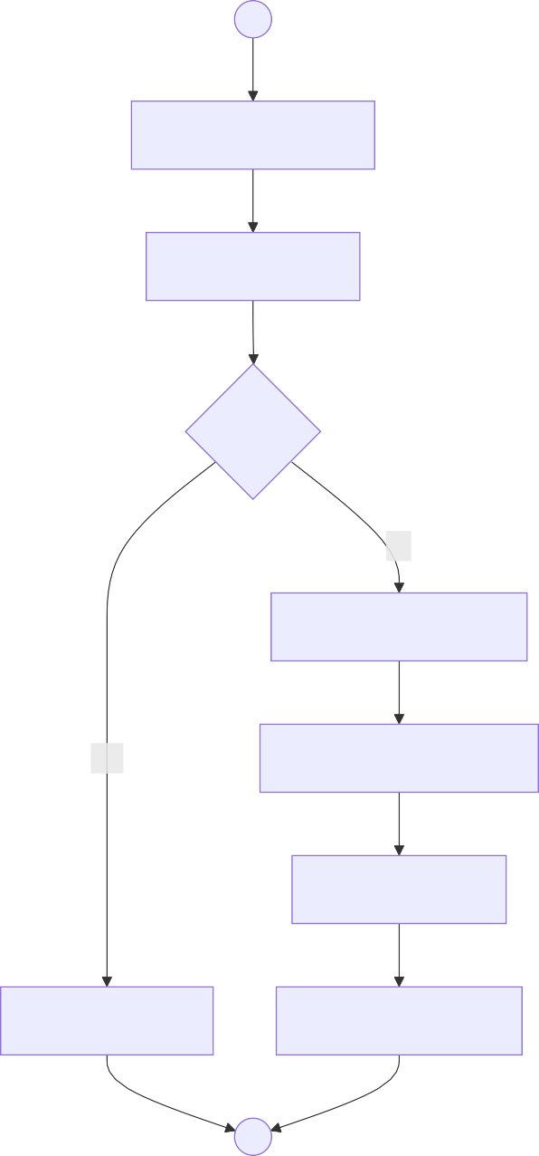
○
Single Portal Entry
Registry Check
Found?
No
Process Application
Yes
Automated Pre-Check
KNQA Decision
Return Existing
Publish to Registry
●
  - End-to-End Qualification Validation



●
Application
Documents
○
Authentication
Payment
Institution Check
KNQF Mapping
Validation Letter
Committee Review
Registry Updated

National Government Coordination
Ministry: Executive Office of the President
Department: National Government Coordination

Attribute | Description
Key Actors | Coordination Officers, MDA Liaison Officers, Regional Coordinators
Function Type | Non-transactional coordination and oversight

  - Coordination Trigger

Identify Stakeholders
Standard Brief
Urgent Brief
Define Scope
Priority
Prepare Brief
Reporting
Security
Reporting Obligation
Set Objectives
Define Deliverables
Set Timeline
Approve Plan
●
Trigger Type?
○
Security Concern
National Priority
  - Information Tasking

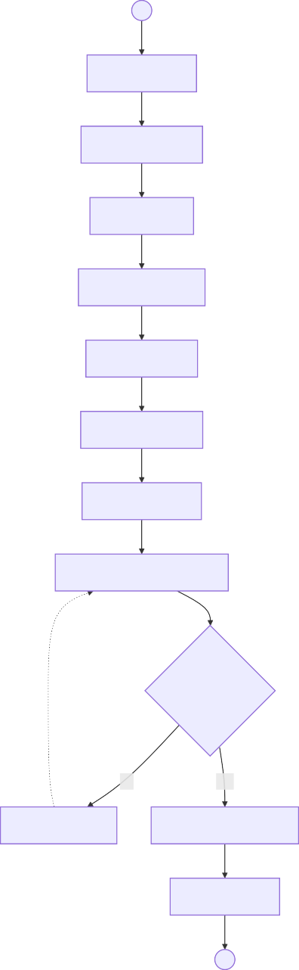
○
Draft Request
Define Template
Set Deadline
Obtain Clearance
Issue to MDAs
Copy to Regions
Log Distribution
Monitor Acknowledgments
All Acknowledged?
No
Yes
Send Reminder
Proceed to Collection
Close Tasking
●
  - Data Collection



●
Create Master Dataset
Merge Submissions
No
Yes
Receive Regional Submissions
Request Resubmission
Complete?
○
Receive MDA Submissions
Log All Submissions
Extract Data
Accept
Standardize Formats
Generate Dashboards
Prepare Situation Report
  - Review and Escalation

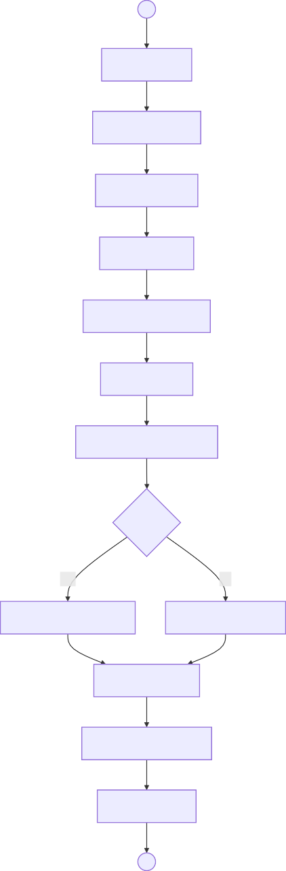
○
Review Data
Identify Patterns
Flag Anomalies
Identify Gaps
Note Inconsistencies
Assess Risks
Document Observations
Critical?
Yes
No
Escalate to Leadership
Routine Processing
Track Response
Document Resolution
Update Status
●
  - End-to-End Coordination



●
Produce Reports
Issue Requests
Define Scope
Prepare Brief
○
Set Deadlines
Track Compliance
Consolidate Data
Receive Submissions
Review Information
Archive

Appendix: Document Summary

# | Ministry | Processes | Key Focus
1 | Children Services | 8 | Child protection workflow
2 | Youth Affairs | 4 | Employment & AGPO
3 | Civil Registration | 5 | Birth, death, certificates
4 | Immigration | 4 | Passport services
5 | Refugee Services | 6 | RSD and documentation
6 | Energy Records | 6 | Records management
7 | MSME Development | 6 | Credit programs
8 | Head Public Service | 5 | Executive coordination
9 | Cabinet Affairs | 4 | CABMEMO, GDMIS
10 | Science Innovation | 5 | Research applications
11 | Culture Ushanga | 5 | Beadwork cooperative
12 | Sports | 4 | Federations, grants
13 | AWWDA | 5 | Water infrastructure
14 | AFA | 4 | Agriculture regulation
15 | Health | 5 | Health information
16 | Education KNQA | 5 | Qualification validation
17 | National Coordination | 5 | MDA coordination
 | TOTAL | 86

